**Version: commons-email-1.5 SLOC:15884**

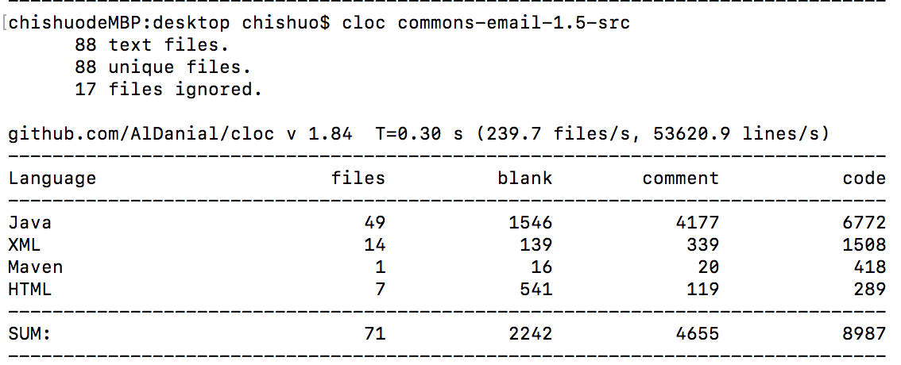

**Version: commons-email-1.4 SLOC:15549**

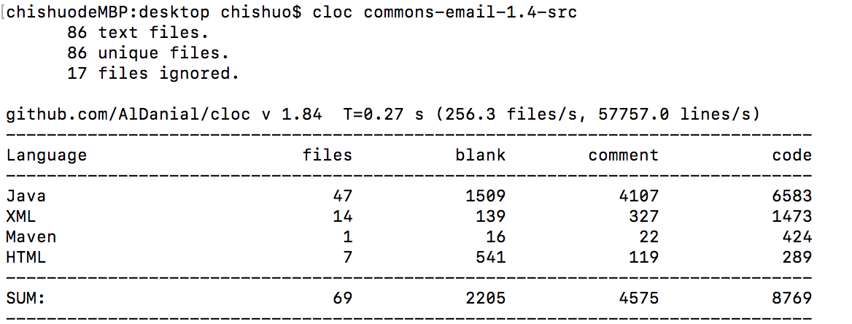

**Version: commons-email-1.3.3 SLOC:15302**

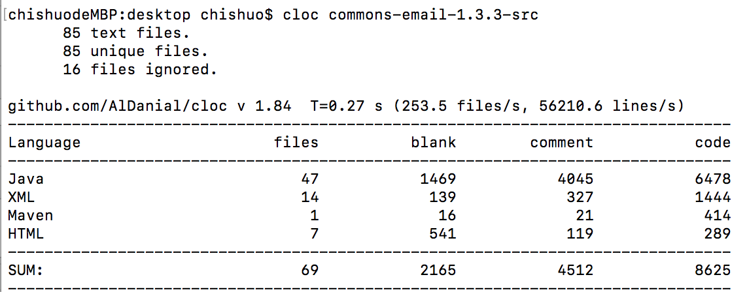

**Version: commons-email-1.2 SLOC:10987**

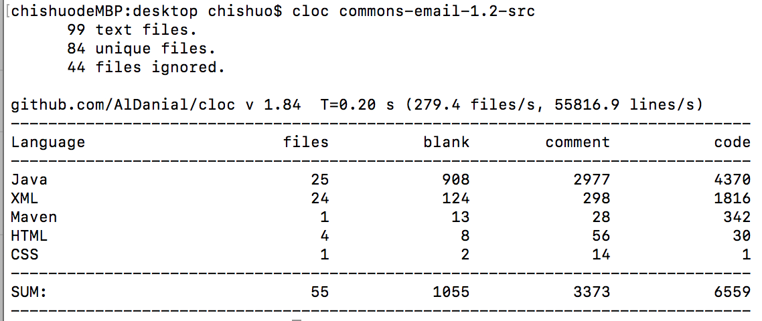

**Version: commons-email-1.1 SLOC:10708**

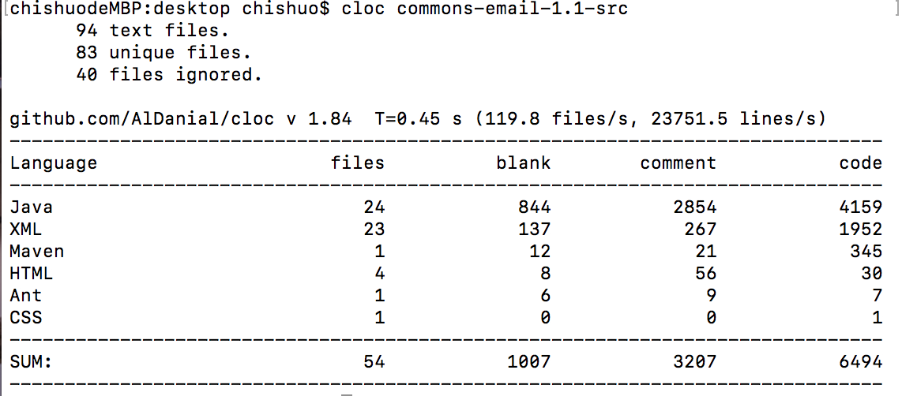

* **Website:** <http://commons.apache.org/email/>
* **Bug-tracking:** <http://issues.apache.org/jira/browse/EMAIL>
* **Subversion repository:** <http://svn.apache.org/repos/asf/commons/proper/email>